# Solving Challenge 4: Alice, Or and The Safe

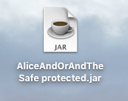

1. Double click *AliceAndOrAndTheSafe.jar*
2. 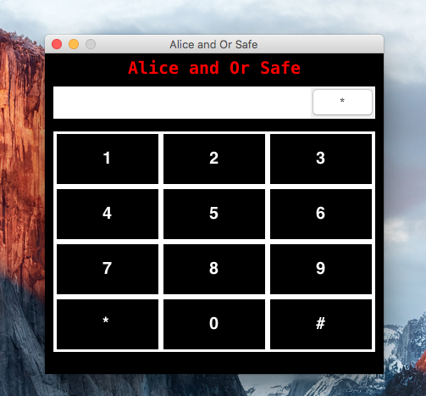A safe-like window pops up:
3. 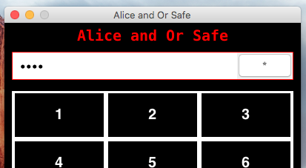Trying some random password colors the password field with red:
4. Clicking around will discover the invisible text box beneath the numbers-pad:



1. Open wire shark for Unix / Linux as suggested in the hidden text,

For windows use RawCap.exe which you can download from:

<http://www.netresec.com/?page=RawCap>

I’m using Mac OSX and everything I’ll show here will work exactly the same on any Unix / Linux Machine, for windows you’ll need to understand there’s a need to download RawCap and use it on the cmd with the command I wrote in the invisible text box, you’ll be able to open the result file with Wireshark and see the same results

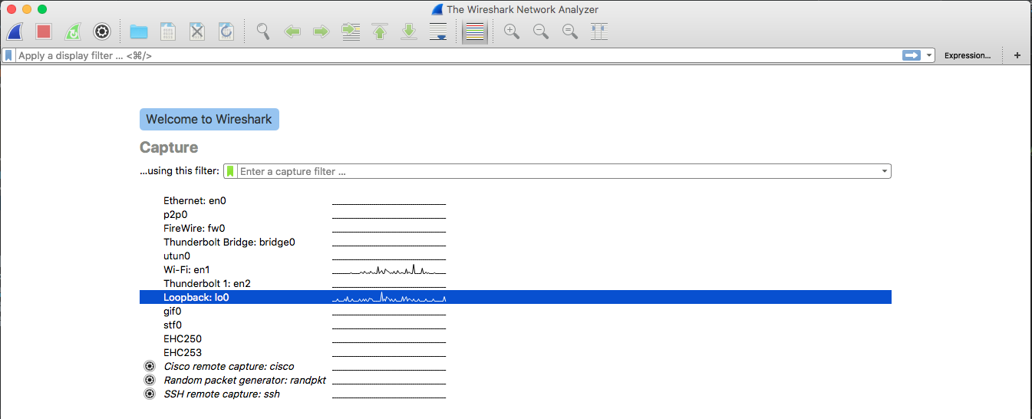

1. Choose the Loopback: lo0 interface as I wrote in the invisible text box:
2. Use the Wire Shark filter as I wrote in the invisible text box to show only the relevant packets:

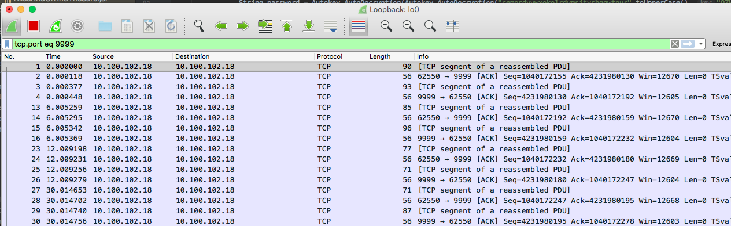

1. Click on the packets to spy on Or and Alice conversation:

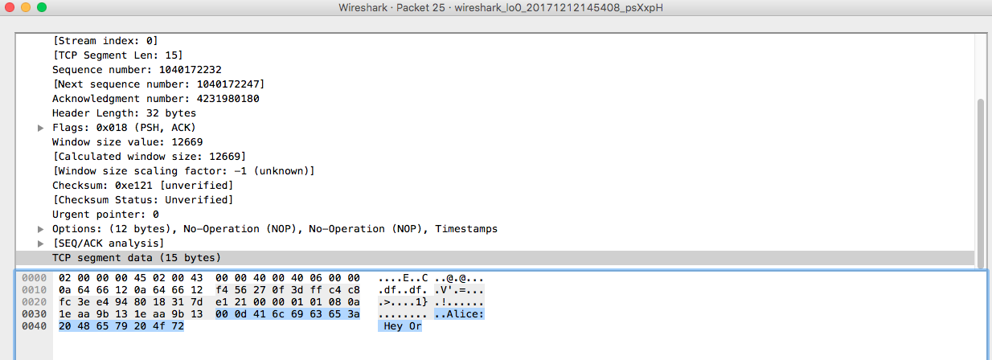

1. Look for some interesting messages:

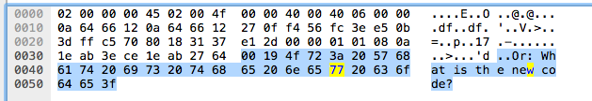

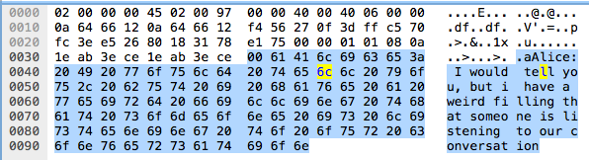Finding out they’re about to send the code for the safe!

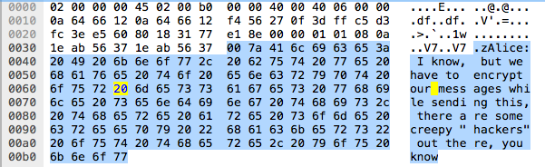Finding out they want to encrypt the code before sending it

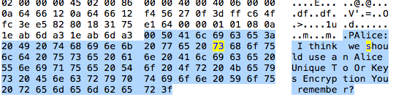

“*Alice Unique To Or Keys Encryption You*” = Auto key!

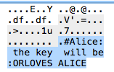

Discovering the encryption key: ORLOVESALICE

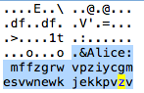The encrypted code:

1. Use [dcode.fr](https://www.dcode.fr/autoclave-cipher) to decode the encrypted code with the key from their conversation ORLOVESALICE:

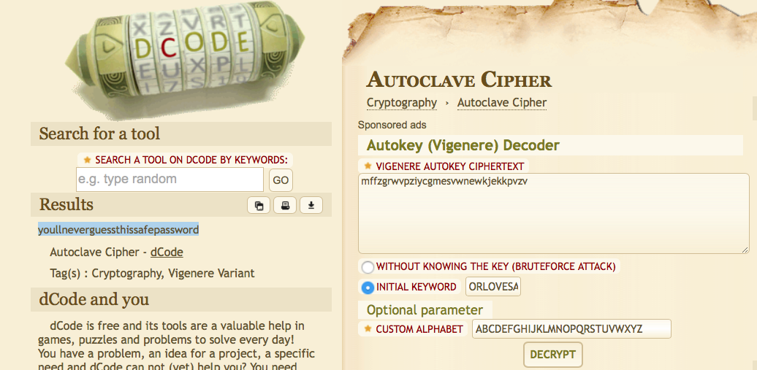

1. 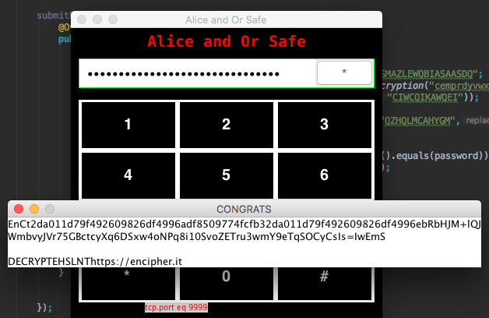Copy the decrypted password and paste it in the safe password field then click the submit button, a CONGRATS window pops up and an encrypted text inside it with an encryption site right below it
2. 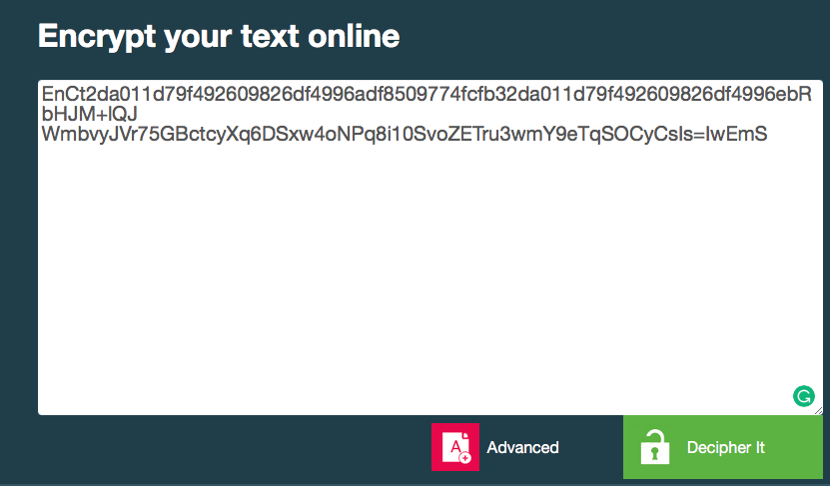Go to the <https://encipher.it> site with your browser and copy the encrypted message into the text box there

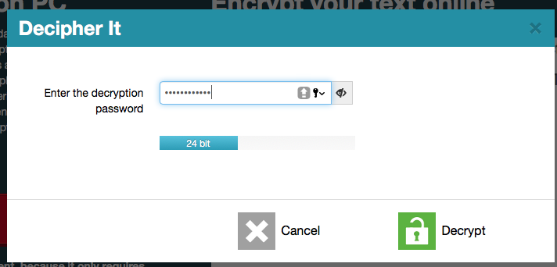

1. Click “Decipher It” and a password will be needed, the best guess will be “ORLOVESALICE”
2. The site will show you a link:

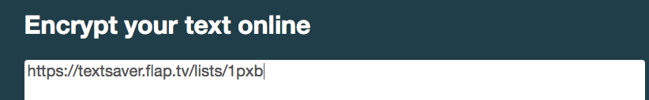

1. Go to <https://textsaver.flap.tv/lists/1pxb> and a password will be needed again

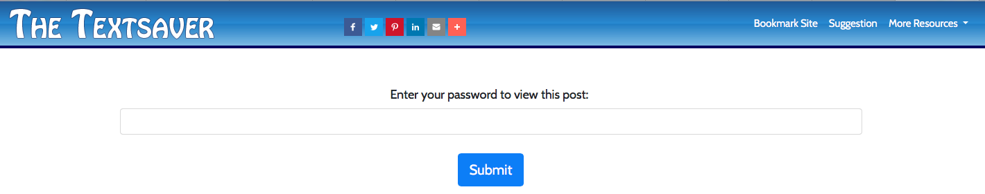

1. We will try ORLOVESALICE as a password and discover the flag:

